DEPARTMENT OF CONSERVATION, FORESTS AND LANDS.
SITES OF GEOLOGICAL AND
GEOMORPHOLOGICAL SIGNIFICANCE
IN THE SHIRE OF OTWAY

Neville Rosengren
1984
FROM PAGES 107-111

11.1 LAKE ELIZABETH AND LANDSLIDE

LOCATION: 11 - 40029l. Five kms southeast of Forrest.

ACCESS: (a) Kaanglang Road (Access road to Barwon River and walking track to outlet of lake).

(b) Thompson Track (Access Track to head of lake).

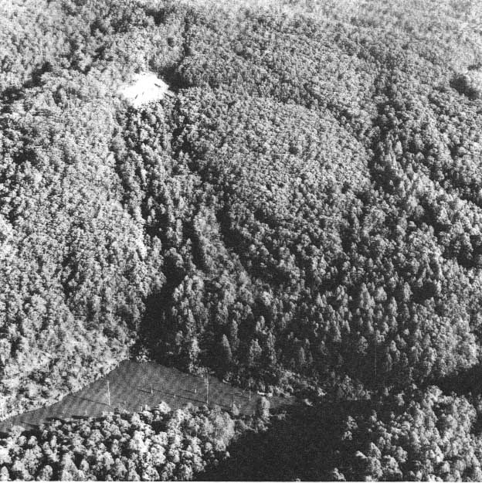
GEOMORPHOLOGY: Lake Elizabeth formed when a landslide blocked the East Branch of the Barwon River on l7th June, 1952 (Plate 30). Originally the lake extended for 1.6 km upstream from the landslide dam and by 8th August 1952 water overtopped the landslide and flowed down a natural spillway. Twelve months later (5th August 1953) following heavy rains, the top 26m of the landslide dam breached and a surge of water carried gravels and boulders several kilometres downstream. The residual dam now contains a lake about one fifth the original volume. The new river channel created by the August 1953 surge is straighter than the original course and is flanked by a levee and terrace of gravels and boulders left by the receding flood.

Plate 30: The landslide dam that blocks the Barwon River to form Lake Elizabeth.
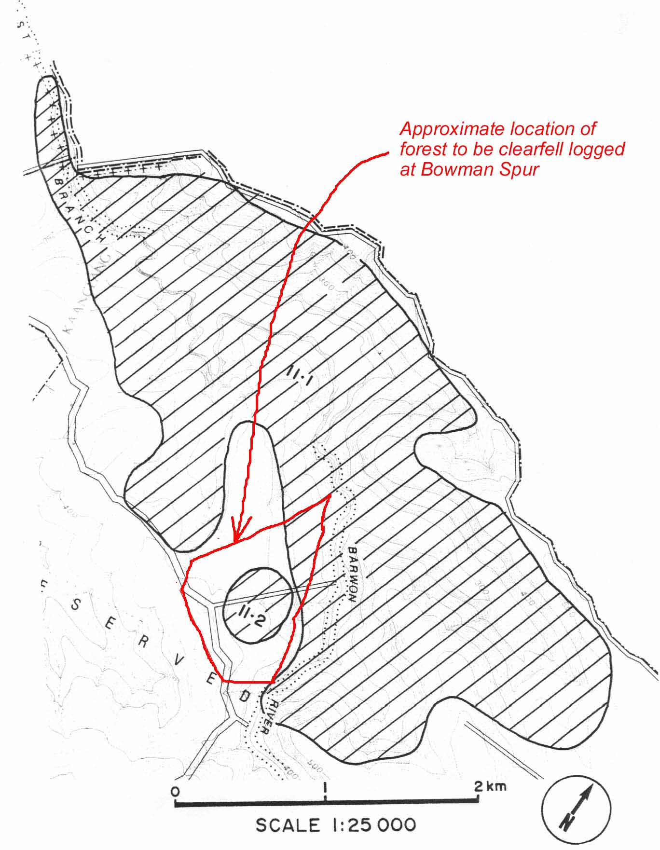

Figure 38: Sites 11.1 and 11.2.
Although now mainly reforested, parts of the landslip surface are now gullied and smaller slips continue to develop on the debris surface. Approximately 30 metres above the main lake is a smaller lake and swamp formed in a back tilted section of the original slide
surface (Plate 31).

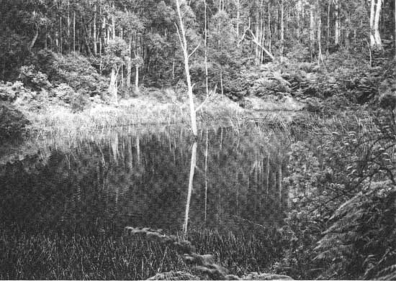
Plate 31: Small lake in back-tilt block above Lake Elizabeth.

SIGNIFICANCE: National. The site is a classic example of a newly formed landslide blocked lake and a number of geomorphological features represent the drainage adjustments upstream and downstream from the landslip. Because the date of the slide is known, it forms a model whereby geological, hydrological and meteorological factors relevant to landslide analysis in the Otways area may be studied. Rates of sediment accumulation in the lake and adjustments in the river profile below the dam are other major fields of geomorphological interest at the site.

MANAGEMENT: Class l. The site and the catchment area of the lake should not be disturbed by clearing, forestry operations, or drainage. Roads around the slide and the catchment of the lake should be sited and designed to minimise runoff and avoid excessive mobilisation of sediment.

EXTRACT FROM PAGE 111

11.2 BARWON RIVER EAST BRANCH LANDSLIP

LOCATION: 11 - 405278. Seven kilometres southeast of Forrest. (See Figure 38)

ACCESS: Kaanglang Road.

OWNERSHIP: Crown Land (Reserved Forest).

GEOMORPHOLOGY: This forested area shows evidence of former large scale landslide activity on a scale comparable to that which blocks the Barwon River at site 11.1.

SIGNIFICANCE: Regional. The site illustrates the nature of landslip activity in forested areas. The nature of the ground surface makes an interesting comparison with the more recent movements at site 11.1.

MANAGEMENT: Class 3. The potential hazard nature of the area should be taken into account when planning roadworks.

EXTRACT FROM PAGES 8-9

MANAGEMENT: Each site has been assessed to determine the extent to which the features of significance are being or could be degraded by current land use, or would be effected by a change in land utilization at or adjacent to the site. This sensitivity of site characteristics is summarized by referring the site to one of three broad classes as explained below.

Class l. These are sites most sensitive to change either because the feature is small and hence easily obscured, removed or detached, or is of 'delicate' structure and so liable to be broken, displaced, mobilized or damaged in a direct physical sense. The interference may be direct or primary, e.g. burial or quarrying of a rock outcrop or the regrading of a slope. It may however be indirect, e.g. vegetation clearing adjacent to a lake alters run-off and groundwater movement and may cause the lake to rapidly infill, or dry out and desiccate and allow deflation of an important pollen bearing peat horizon.

Class 2. These are sites of moderate sensitivity which may tolerate some degree of accelerated change and still retain the essential features of significance. This may be due to the site being large or consisting of numerous similar forms which are independent or self-contained in the properties they display.

Class 3. These typically are large sites displaying a macro variation in relief or geology which is unlikely to be obscured or removed. The site may demonstrate a major terrain pattern, e.g. a recurrence of ridges and valleys, and intensive or point disturbance will not alter this essential broad geometrical characteristic.

